EXPLORATION OF TCP&UDP

# AIM:TO establish the exploration of tcp & udp using packet tracer

# REQUIREMENTS:

*switches -1

*pc’s-4

* Server-1

*cable

# PROCEDURE:

1.connect all the devices with cable

2.create the ip address

3.and next create the email to web and client

4.and set up the web address by own and create the web

5.and create two for sending and reciving the mails

6.now send the message to the other by configuring and next go the client and check in the mail for reply .

7.the message appears in the mail

8.and strat the ftp process and create the prompt

# IMPLEMENTATION:

## STEP:1

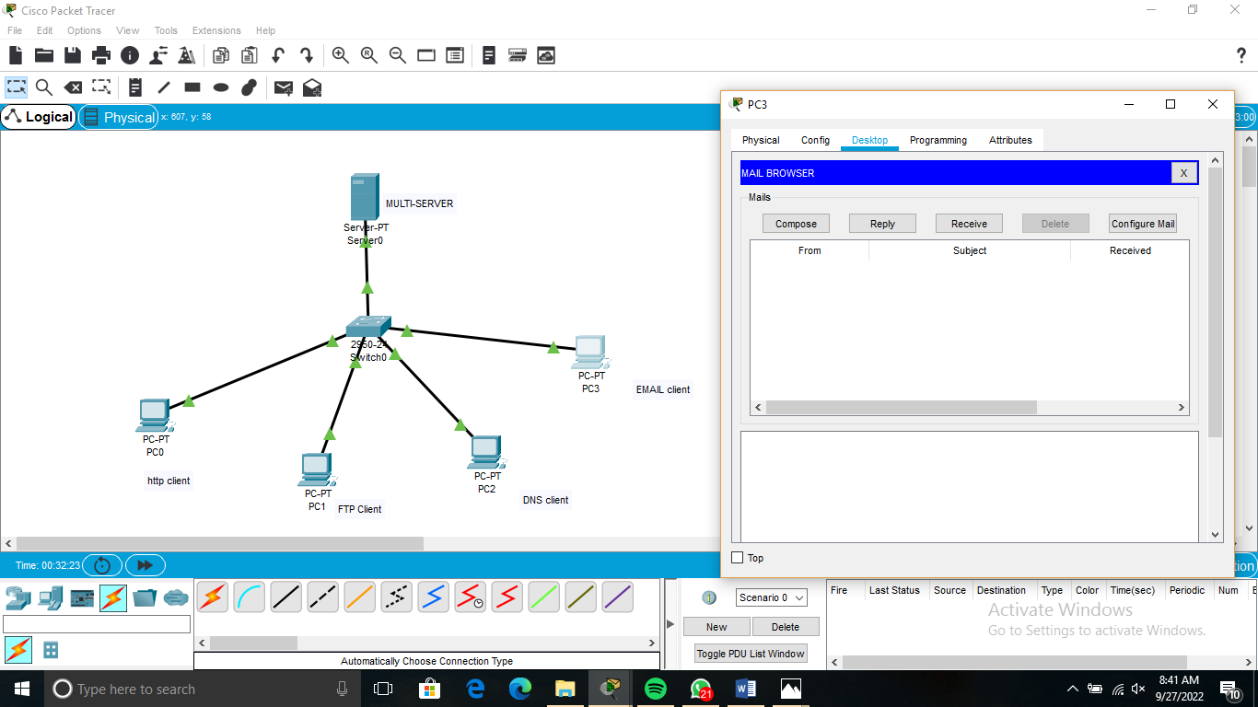

## STEP:2

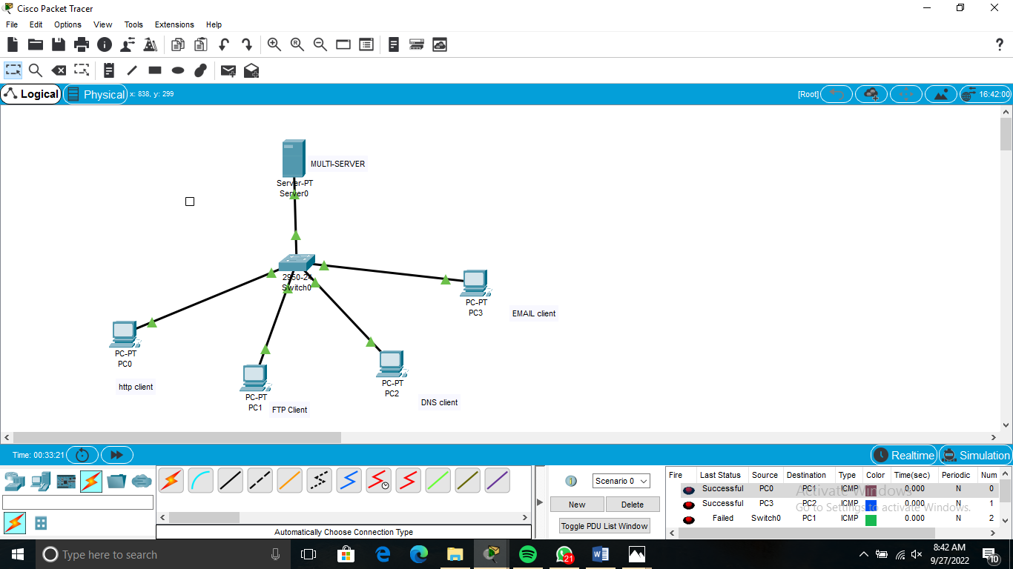

## STEP;3

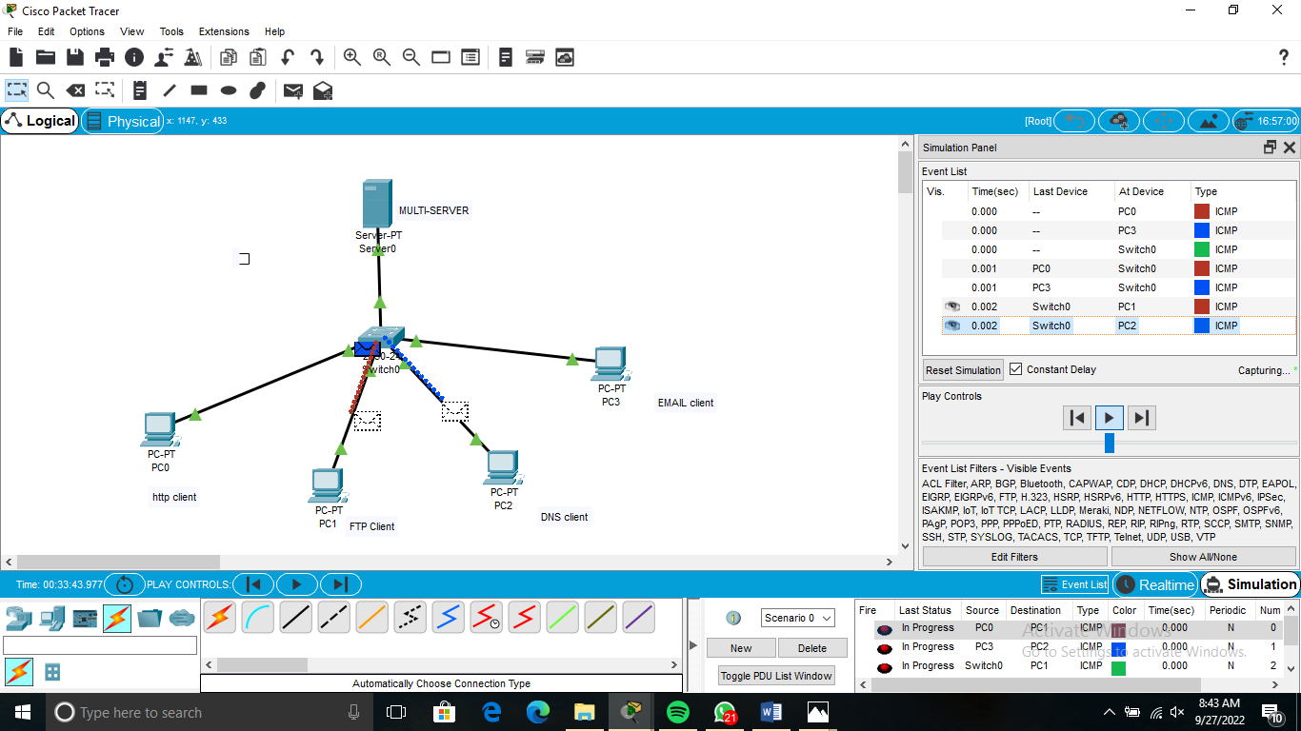

# RESULT:

Thus the exploration of ftp & udp was established and the communication

among the machines using ping command is verified successfully